Load Balancer
This also implements an Application manager for the JSF servlet.
Content:
- Overview
- JSF server configuration
- Download jar file

Overview
It Gives a picture of all the pages requested to a given URL
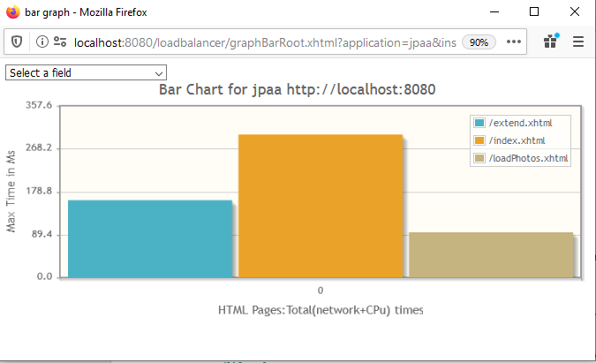
Click on one of the bars and it will take you to the request made for that page (index.xhtml)
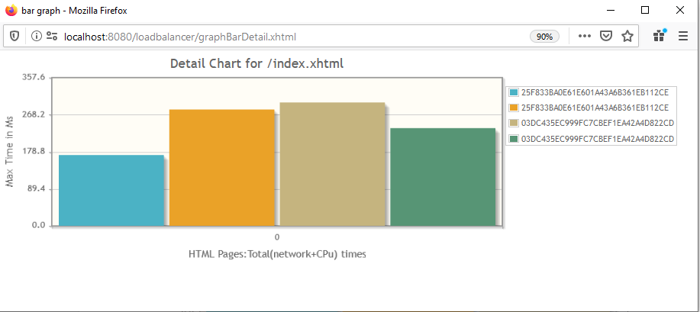

Every bar represents the page executed by a given session. See legend on the upper right.
If you click one of the bars you will get all pages with the related time stamps (bars).
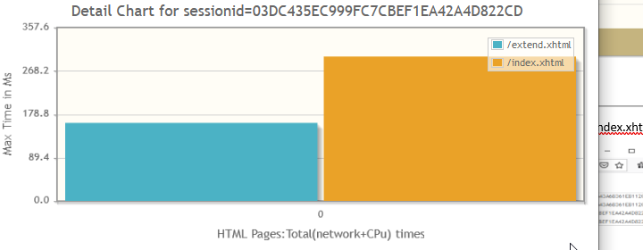

JSF server configuration
Set environmental variable:
LBHANDSHAKE=http://ourfamilycontacts.com/loadbalancer/loadinstance/includes/js/lbhandshake.js
Test:
LBHANDSHAKE=http://10.0.0.246:8080/loadbalancer/loadinstance/includes/js/lbhandshake.js
faces-config.xml
<lifecycle>
<phase-listener>com.assoc.jad.loadbalancer.lbinstance.LifeCycleListener</phase-listener>
</lifecycle>
Web.xml
<filter>
<filter-name>jsftrace filter</filter-name>
<filter-class>com.assoc.jad.loadbalancer.lbinstance.LoadBalancerFilter</filter-class>
</filter>
<filter-mapping>
<filter-name>jsftrace filter</filter-name>
<servlet-name>Faces Servlet</servlet-name>
<url-pattern>/*</url-pattern>
</filter-mapping>

JVM:
--add-opens jdk.management/com.sun.management.internal=ALL-UNNAMED

Download jar file
Jar-file: /jadallfolders/jadtemp/Loadbalancer.jar

This application will also provide you with time frames for request made from your jsf application to the user

